HERO CHAMPIONSHIPS 2022
Rules and Regulations

Important Notes

- If your child is aged 7+ they will be considered a Junior and must participate in the Junior categories rather than the Mini Hero categories
- If a student is blue belt they will automatically be considered as a Junior and not a Mini Hero regardless of age

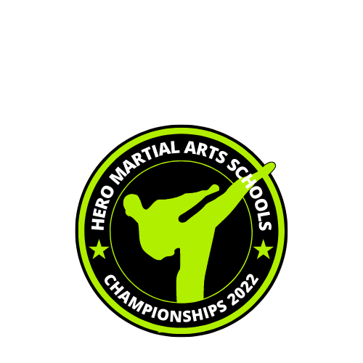
JUNIOR & ADULT CATEGORIES 7yrs above

Hand Drills

- Students must perform (in this order):
  - 1st hand drill (in your own time) – winner will then be announced for this part only
  - 2nd hand drill (in your own time) – winner will then be announced for this part only
  - If it is a tie i.e. both students wins a round each, students will be asked to perform their 3rd choice hand-drill. This must be different from the previous 2 hand-drills.
- White, Yellow & Orange Stripe Belts may repeat Hand-Drill 1 for each round
- White, Yellow & Orange Stripe Belts may repeat Hand Drill 1 if they are required to perform for a 3rd, deciding round.
- Orange, Green Stripe and Green Belts may repeat Hand Drill 1 or 2 if they are required to perform for a 3rd deciding round
- Hand-drills must be taken from the syllabus. Please take note below of the hand drills the student will be asked to perform.

Belt Level: Hand-Drills:

White 1
Yellow 1
Orange Stripe 1
Orange 1 & 2
Green Stripe 1 & 2
Green 1 & 2
Blue Stripe 1, 2 & 3
Blue 1, 2 & 3
Red Stripe 1, 2 & 3
Red Belt & Above 2, 3 & 4

- The Hand Drills will be judged by a panel on the following areas:
- Rhythm
- Power
- Technique
- Accuracy

- This category will go straight through until we have a winner

Punching & Kicking Combinations

- Students must perform (in this order):
  - 1st punching & kicking combination (in your own time) – winner will then be announced for this part only
  - 2nd punching & kicking combination (in your own time) – winner will then be announced for this part only
  - If it is a tie i.e. both students wins a round each, students will be asked to perform their 3rd choice of punching & kicking combination. This must be different from the previous punching & kicking combinations.

- White belts may repeat punching & kicking combination 1 for each round.
- Yellow belts may repeat punching & kicking combination 1 or 2 if they are required to perform for a 3rd, deciding round.
- All punching & kicking combinations must be taken from the syllabus. Please take note below of the punching & kicking combinations student will be asked to perform.

Belt Level: Punching & Kicking Combinations:

White 1
Yellow 1 & 2
Orange Stripe 1, 2 & 3
Orange 2, 3 & 4
Green Stripe 3, 4 & 5
Green 4, 5 & 6
Blue Stripe 5, 6, & 7
Blue 6, 7 & 8
Red Stripes & Above 7, 8 & 9

- The punching & kicking combinations will be judged by a panel on the following areas:
- Enthusiasm
- Power
- Technique
- Accuracy

- This category will go straight through until we have a winner

Point Stop Sparring

- Please note this category is for orange belts and above only.
- Blitz sparring pads only - head guards, gloves, feet, shin and groin guards are compulsory in this competition. Student wearing any other style of Martial Arts safety equipment will not be able to take part.
- If a student is missing any required safety equipment they have 2 minutes to acquire what is necessary (length of one bout).
- Gum shields must be worn for sparring
- Full Hero official uniform must be worn (white or Hero+)

- Each category will be decided by points knock-out
- Each bout will consist of 2 x 1minute rounds
- When a point is called the timer will be stopped and will resume when the round continues
- A fighter has to win by 1 clear point with the first fighter to 7 points being declared the winner (if a fighter does not reach 7pts by the end of the rounds but is ahead on points they are the winner).
- If one fighter is winning by 5 points, then that fighter may automatically win using the 5 point spread system (referees discretion).
- If the bout is tied after the 2 x 1minute rounds = sudden death (time unlimited).
- If a fighter comes off the mat 3 times in a row then their opponent will get 1 point
- This category will go straight through until we have a winner

Scoring Points:
Punch to head / body = 1 point
Kick to body = 1 point
Kick to head = 2 points
Jumping kick to head = 3 points
Spinning kick to head = 3 points

- To score a point with a hand technique, fighters must only use a straight punch (controlled) / controlled back-fist. Therefore, hooks, uppercuts and any spinning hand techniques are illegal
- Contact may only be made using hands and feet
- No contact to face / below the belt / back / back of head
- No sweeping or grabbing
- If the referee sees continuous facial contact then scoring to the head with hand techniques will not counted.

Warnings and Misconduct

- The referee may give up to 3 warnings for one misconduct or rule break.
- On the third warning 1 point will be added to the opponent’s score.
- Following this, 1 point will be awarded for every warning
- The judges decision is final
- If a referee suspects a fighter of ‘dirty tricks’ (a move carried out with the intent to harm) then the fighter may be instantly disqualified.

Forms

- Each student will be asked to display their chosen form

White, Yellow & Orange Stripe - Form 1
Orange, Green Stripe & Green - Forms 1 or 2
Blue Stripe, Blue & Red Stripe - Forms 1, 2 or 3
Red Belts & Above - Forms 2, 3 or 4

- The winner will be decided on a knock-out basis using a score system of 1 to 10.
- This category will go straight through until we have a winner
- Students may be asked to perform this several times and will be judged on the following
- Rhythm
- Power
- Technique
- Accuracy

Pair Forms

- Students will be asked to display their chosen form

White, Yellow & Orange Stripe - Form 1
Orange, Green Stripe & Green - Forms 1 or 2
Blue Stripe, Blue & Red Stripe - Forms 1, 2 or 3
Red Belts & Above - Forms 2, 3 or 4

- The winner will be decided on a knock-out basis using a score system of 1 to 10.
- This category will go straight through until we have a winner
- Students may be asked to perform this several times and will be judged on the following
- Rhythm
- Power
- Technique
- Accuracy

10 Kick Combination

- Students will be asked to perform their 10 kick combination individually
- Students will be judged on 10 kicks only (no gymnastics will be judged).
- Students may perform techniques moving in a forward direction but MUST NOT travel in a different direction E.G. students must either remain stationary or move in a straight line.
- Winners will be decided on a knock-out basis
- The winner will be decided upon:
  - Technique
  - Creativity
  - Enthusiasm
  - Control

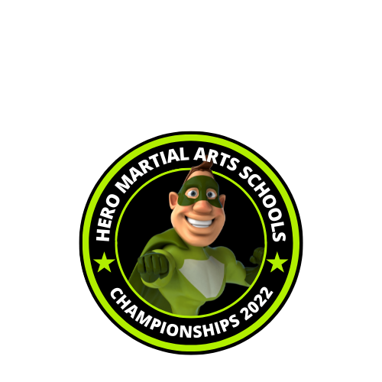
MINI HERO
CATEGORIES 3-6yrs

Mini Hero Hand Drills

- Students must perform (in this order):
  - 1st hand drill (in your own time) – winner will then be announced for this part only
  - 2nd hand drill (in your own time) – winner will then be announced for this part only
  - If it is a tie i.e. both students wins a round each, students will be asked to perform their 3rd choice hand-drill. This must be different from the previous 2 hand-drills.
- White, Yellow & Orange Stripe Belts may repeat Hand-Drill 1 for each round
- White, Yellow & Orange Stripe Belts may repeat Hand Drill 1 if they are required to perform for a 3rd, deciding round.
- Orange, Green Stripe and Green Belts may repeat Hand Drill 1 or 2 if they are required to perform for a 3rd deciding round
- Hand-drills must be taken from the syllabus. Please take note below of the hand drills the student will be asked to perform.

Belt Level: Hand-Drills:

White 1
Yellow 1
Orange Stripe 1
Orange 1 & 2
Green Stripe 1 & 2
Green 1 & 2
Blue Stripe 1, 2 or 3
Hero Badge 1 1, 2 or 3
Hero Badge 2 1, 2 or 3
Hero Badge 3 1, 2 or 3

Mini Hero 5 Kick Combination

- Students will be asked to perform their 5 kick combination individually
- Students will be judged on 5 kicks only (no gymnastics will be judged).
- Students may perform techniques moving in a forward direction but MUST NOT travel in a different direction E.G. students must either remain stationary or move in a straight line.
- Winners will be decided on a knock-out basis
- The winner will be decided upon:
  - Technique
  - Creativity
  - Enthusiasm
  - Control

Mini Hero Wavemaster

All Mini Heroes will be asked to perform any technique on the Wavemaster for 10 seconds

- Winners will be decided on a knock-out basis
- The winner will be decided upon:
  - Technique
  - Creativity
  - Enthusiasm
  - Control

Mini Hero Flying Side Kick

All Mini Heroes will be asked to perform a flying side kick to a kick shield.

- Winners will be decided on a knock-out basis
- The winner will be decided upon:
  - Power
  - Technique
  - Enthusiasm
  - Control

Mini Hero Punching & Kicking Combinations

- Students must perform (in this order):
  - 1st punching & kicking combination repeated 3 times (in your own time) – winner will then be announced for this part only
  - 2nd punching & kicking combination repeated 3 times (in your own time) – winner will then be announced for this part only
  - If it is a tie i.e. both students wins a round each, students will be asked to perform their 3rd choice of punching & kicking combination. This must be different from the previous punching & kicking combinations.

- White belts may repeat punching & kicking combination 1 for each round.
- Yellow belts may repeat punching & kicking combination 1 or 2 if they are required to perform for a 3rd, deciding round.
- All punching & kicking combinations must be taken from the syllabus. Please take note below of the punching & kicking combinations student will be asked to perform.

Belt Level: Punching & Kicking Combinations:

White 1
Yellow 1 & 2
Orange Stripe 1, 2 & 3
Orange 2, 3 & 4
Green Stripe 3, 4 & 5
Green 4, 5 & 6
Blue Stripe & Badges 1,2 & 3 5, 6, & 7

- The punching & kicking combinations will be judged by a panel on the following areas:
- Enthusiasm
- Power
- Technique
- Accuracy

- This category will go straight through until we have a winner

